Whatweb

1. Tool Overview
- Description: WhatWeb is a next-generation web scanner that identifies technologies used by websites including content management systems (CMS), blogging platforms, statistic/analytics packages, JavaScript libraries, web servers, and embedded devices.
- Category: Reconnaissance, Fingerprinting, Information Gathering
- Developer/Maintainer: Andrew Horton (urbanadventurer) and the WhatWeb contributors
- License: GNU General Public License v2.0 (GPL-2.0)
- Official Resources:
  - GitHub Repository
  - Wiki
  - Official Website

2. Installation Guide
- System Requirements:
  - Operating Systems: Linux, macOS, Windows (with Ruby)
  - Ruby 2.x or newer
  - Dependencies: ruby-dev, libcurl4-openssl-dev, make, zlib1g-dev, liblzma-dev
- Installation Methods:
Using Git:
bash
git clone https://github.com/urbanadventurer/whatweb.git
cd whatweb
  - bundle install
On Kali Linux/Debian/Ubuntu:
bash
apt-get update
  - apt-get install whatweb
  - Using Ruby Gems:
bash
gem install whatweb
Docker Installation:
bash
docker pull urbanadventurer/whatweb
  - docker run -it urbanadventurer/whatweb whatweb example.com
- Verification:
bash
whatweb --version

3. Basic Configuration
- Initial Setup: No specific initial setup required after installation.
- Configuration Files:
  - Plugin files located in <installation_path>/plugins/
  - Custom plugins can be added to the plugins directory
- Environment Variables: No specific environment variables required.
- Default Credentials: Not applicable (no authentication needed for the tool itself)

4. Core Functionality
- Key Features:
  - Identifies web technologies, including CMS, blogging platforms, analytics packages
  - Over 1800 plugins for fingerprinting
  - Supports multiple targets and recursive website spidering
  - Configurable aggression levels (stealth to aggressive)
  - Plugin system for easy customization
  - Various output formats (JSON, XML, SQL, etc.)
  - Ability to scan through proxies or use custom user agents
  - Batch mode for scanning multiple targets
- Basic Usage:
bash
whatweb https://example.com
- Command Structure:
whatweb [options] <target>
Where:
  - options are various command-line flags
  - <target> is a URL, IP address, IP range, or filename containing targets
- Common Parameters:
  - -a - Aggression level (1-4, higher = more aggressive)
  - -v - Verbose output
  - -i - Take input from a file
  - -o - Output to file
  - --log-json - Log in JSON format
  - --log-xml - Log in XML format
  - --log-sql - Log in SQL format
  - --user-agent - Set custom user agent
  - --max-threads - Set maximum number of threads
  - --proxy - Use proxy server
  - --grep - Search for string in the results

5. Test Scenarios & Commands

Modified whatweb Commands

Information Gathering: Enumerate Web Applications

whatweb -v https://example.com
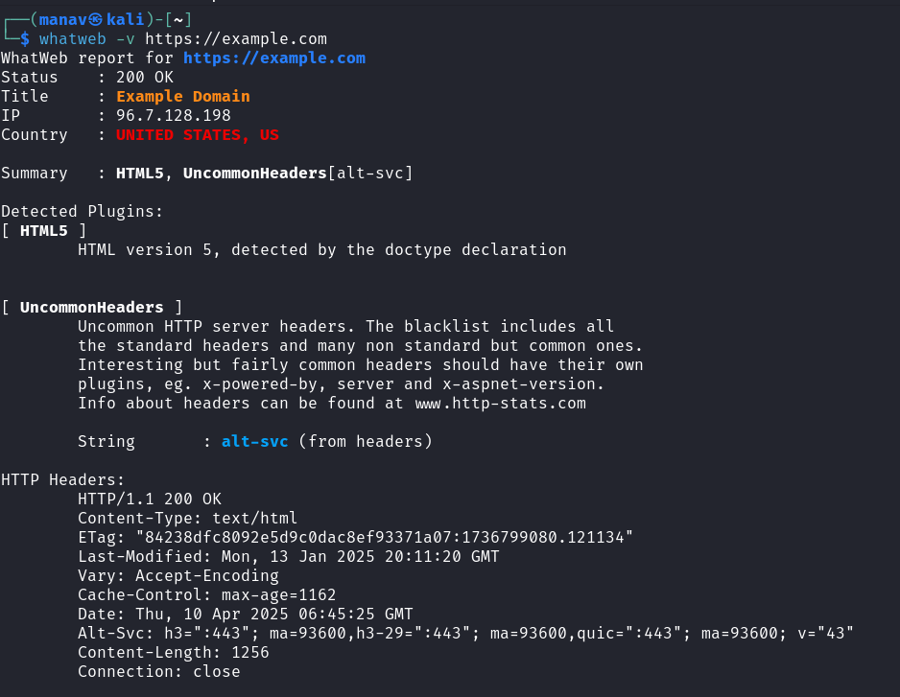

Example.com WhatWeb Analysis

Output Summary
The command reveals detailed information about example.com's web technologies, HTTP headers, and server characteristics using the WhatWeb reconnaissance tool.

Site Information

Basic Site Details
- Status: 200 OK (Site is operational)
- Title: Example Domain
- IP Address: 96.7.128.198
- Location: United States, US

Technical Summary
- Technologies: HTML5, UncommonHeaders
- Special Headers: alt-svc

Technology Details

HTML5
- Detected via doctype declaration
- Modern web standard implementation
- Indicates contemporary site development

UncommonHeaders
- Detected non-standard HTTP headers
- Specifically found "alt-svc" header
- This header enables Alternative Services specification

HTTP Headers Analysis

Standard Headers
- HTTP/1.1 200 OK: Standard success response
- Content-Type: text/html
- ETag: "84238dfc8092e5d9c0dac8ef93371a07:1736799080.121134"
- Last-Modified: Mon, 13 Jan 2025 20:11:20 GMT
- Vary: Accept-Encoding
- Cache-Control: max-age=1162
- Date: Thu, 10 Apr 2025 06:45:25 GMT
- Content-Length: 1256
- Connection: close

Non-Standard Headers
- Alt-Svc: h3=":443"; ma=93600,h3-29=":443"; ma=93600,quic=":443"; ma=93600; v="43"
  - Indicates HTTP/3 support
  - QUIC protocol implementation
  - Multiple versions supported (h3, h3-29)
  - ma=93600: Max age of 93600 seconds (26 hours)

Security Assessment
- Server Information Disclosure:
  - IP address publicly visible
  - Geographic location identifiable
  - HTTP version exposed
- Infrastructure Insights:
  - HTTP/3 (QUIC) implementation suggested by Alt-Svc header
  - Long cache times (max-age=1162)
  - Possible CDN usage (based on header patterns)
- Red Teaming Implications:
  - Alt-Svc header reveals protocol capabilities
  - Limited technology stack identified (minimal attack surface)
  - Server headers deliberately minimized (good security practice)
  - No server software or version disclosed (security by obscurity)

Related Techniques for Red Team Documentation
- Extended Reconnaissance:
  - Port scanning to identify additional services
  - SSL/TLS analysis with tools like testssl.sh
  - Subdomain enumeration to discover related assets
  - Check for CORS misconfigurations
- HTTP/3 Testing Specifics:
  - Test for HTTP/3 protocol-specific vulnerabilities
  - Probe QUIC implementation for weaknesses
  - Use specialized HTTP/3 clients for deeper inspection
- Defensive Recommendations:
  - Consider removing ETag for enhanced privacy
  - Implement security headers (missing Content-Security-Policy, X-Frame-Options)
  - Review cache-control settings for sensitive content
  - Consider more restrictive CORS policies
- Additional Investigation Areas:
  - Test for HTTP request smuggling vulnerabilities
  - Check for path traversal vulnerabilities
  - Verify proper input validation on any forms
  - Test for open redirects
This WhatWeb analysis reveals that example.com employs a modern but minimalist technology stack, with HTTP/3 capability and careful control over information disclosure through headers.

whatweb -a 3 -v https://mozilla.org
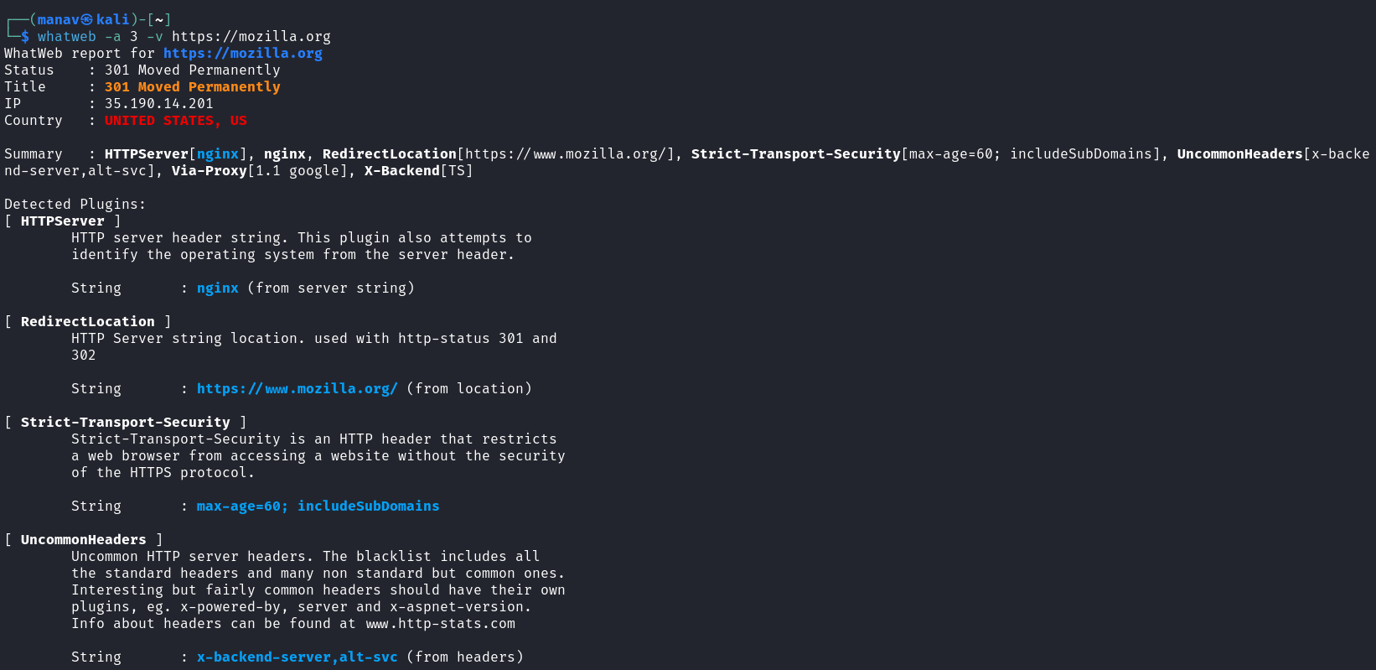
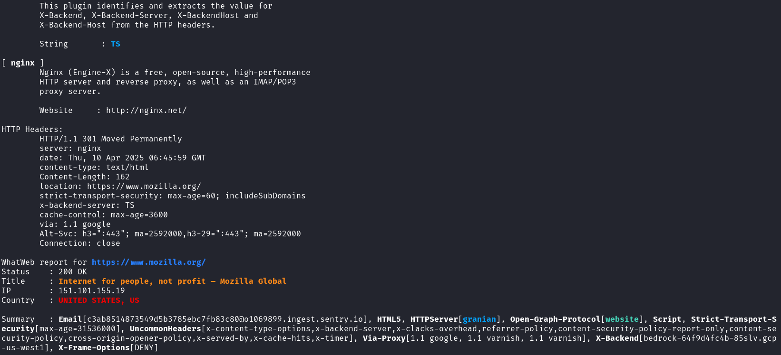
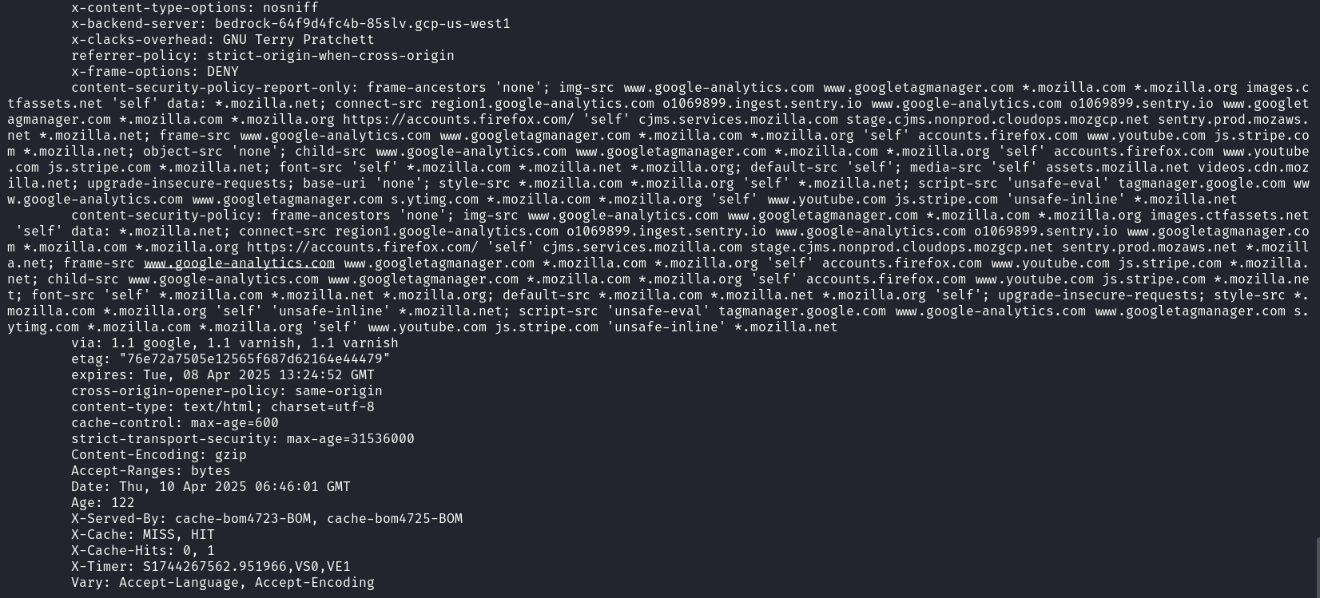

whatweb -i domains.txt -v
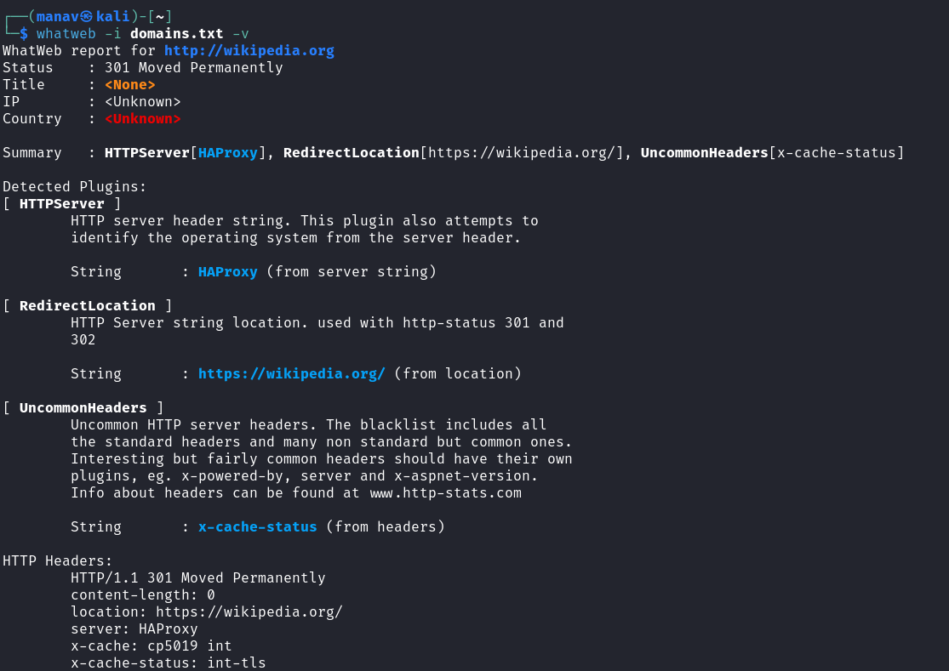

whatweb 93.184.216.34-93.184.216.40
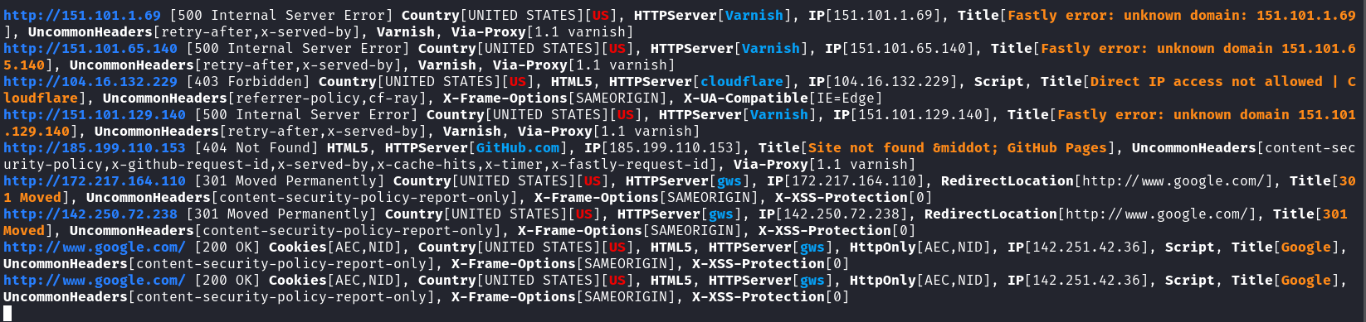

whatweb https://example.com:443 https://example.com:80 https://example.com:8080

whatweb -a 3 --log-json=results.json https://www.wikipedia.org

whatweb -a 3 --grep "Apache" https://apache.org
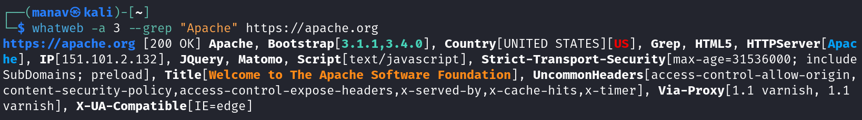

whatweb -a 3 --user-agent="Mozilla/5.0 (Windows NT 10.0; Win64; x64)" https://httpbin.org/user-agent

whatweb -a 3 --user=admin --password=password https://httpbin.org/basic-auth/admin/password
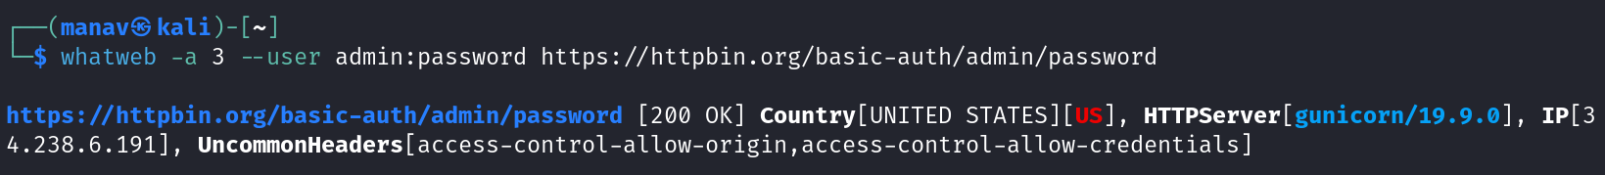

6. Troubleshooting
- Common Errors:
  - SSL/TLS Errors:
    - Issue: SSL certificate verification problems
    - Solution: Use --no-check-certificate option
  - Slow or Hanging Scans:
    - Issue: Scan taking too long or hanging
    - Solution: Reduce aggression level with -a or set a timeout with --max-run-time
  - Memory Issues:
    - Issue: Out of memory when scanning large sites
    - Solution: Reduce the number of threads with --max-threads or scan smaller batches
  - Plugin Errors:
    - Issue: Plugin failures
    - Solution: Update WhatWeb to the latest version or disable problematic plugins with --disable-plugin
- Debugging:
  - Use -v for verbose output
  - Use --debug for detailed debugging information
  - Check plugin errors with --log-errors option
- Support Resources:
  - GitHub Issues
  - Wiki Documentation

7. Security Considerations
- OPSEC Concerns:
  - Default User-Agent is recognizable ("WhatWeb/X.X.X")
  - High aggression levels can generate significant traffic
  - Some targets might log or block scanning attempts
- Detection Methods:
  - Detection of specific User-Agent strings
  - Pattern matching for rapid sequential requests
  - Monitoring for requests to non-linked resources
  - WAF rules specifically targeting scanning patterns
- Mitigation Techniques:
  - Use custom User-Agent with --user-agent
  - Use lower aggression levels (1-2) with -a
  - Slow down scanning with --wait option
  - Use proxies or Tor with --proxy
  - Distribute scanning across multiple source IPs
  - Scan during periods of high traffic to blend in

8. References and Additional Resources
- Cheat Sheet:
  - Basic scan: whatweb example.com
  - Aggressive scan: whatweb -a 3 example.com
  - Scan multiple sites: whatweb -i targets.txt
  - JSON output: whatweb --log-json=results.json example.com
  - Stealth mode: whatweb -a 1 --wait 10 example.com
  - Grep for specific technology: whatweb --grep "WordPress" example.com
- Related Tools:
  - Wappalyzer - Browser extension for technology identification
  - BuiltWith - Web technology identification service
  - Shodan - Search engine for Internet-connected devices
  - Netcraft - Provides web server fingerprinting
  - Nikto - Web server scanner
- Further Reading:
  - OWASP Information Gathering
  - Web Application Fingerprinting Techniques
  - Morning Star Security Blog
- Community Resources:
  - WhatWeb Wiki
  - Custom Plugins Development Guide

